Sheriff’s Office Community Programs Video:

Click [here](https://www.canva.com/design/DAGTMcp3SL0/OAl24uPTU-GpvnWP-5iaQA/watch?utm_content=DAGTMcp3SL0&utm_campaign=designshare&utm_medium=link&utm_source=editor)

[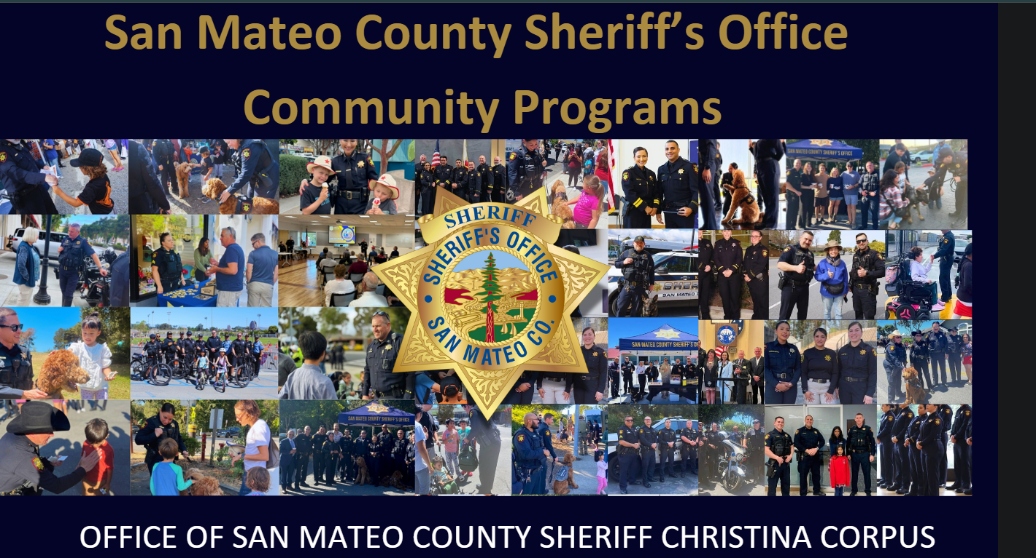](https://www.canva.com/design/DAGTMcp3SL0/OAl24uPTU-GpvnWP-5iaQA/watch?utm_content=DAGTMcp3SL0&utm_campaign=designshare&utm_medium=link&utm_source=editor)